SIMATS ENGINEERING
ASSESSMENT TOOL 2
Course Name | INTERNET PROGRAMMING
Course Code | CSA43
Name | K VENKATA SIVA PRASAD
Register Number | 192325106
Question 1: Responsive Navigation Bar Design
An e-commerce website requires a responsive navigation bar that adapts across desktop, tablet and mobile devices. (a) Identify key components required in a navigation bar for an e-commerce website. (b) Design a responsive navigation bar using appropriate CSS techniques. (c) Demonstrate how the navigation adapts to smaller screens (e.g., hamburger menu). (d) Evaluate the usability and suggest improvements for better user experience.
SOLUTION:
(a) Key components of an e-commerce navigation bar
A shopper visits an online store to find a product, compare it and buy it. The navigation bar must therefore make searching, browsing and checkout reachable from every page. The components used in this design are listed below.
Component | Purpose | Used in the design
Brand logo | Identifies the store; click returns to the home page | “KartZone” text logo
Primary menu | Gives access to the main sections of the site | Home, Categories, Deals, My Orders
Search bar | Lets the user jump directly to a product; the most used feature of a shop | Search box with “Go” button
Cart with item count | Shows cart status and leads to checkout | Cart link with badge “3”
Account / Login | Gives access to profile, orders and wishlist | Login link
Hamburger toggle | Collapses the menu to save space on phones | Button shown only on small screens
Announcement strip | Shows offers such as free delivery | Top bar above the navbar

(b) Responsive navigation bar using CSS techniques
The navbar is designed mobile-first: the basic CSS describes the phone layout and a single media query at 768px upgrades it for tablets and desktops. The following techniques are used.
CSS technique | Why it is used
display:flex with flex-wrap:wrap | Places logo, icons and search in rows and lets items move to a new line on a narrow screen.
order property | Re-arranges the same HTML into a different visual order on mobile and desktop without changing the markup.
gap and CSS variables (:root) | Gives equal spacing and keeps colours in one place for easy theming.
@media (min-width: 768px) | Switches the menu from a stacked list to a horizontal row and hides the hamburger button.
position: sticky; top: 0 | Keeps the navbar (search and cart) visible while the page is scrolled.
min-height: 44px on links | Creates comfortable touch targets for fingers.
JavaScript class toggle + aria-expanded | Opens and closes the mobile menu and informs screen readers of its state.

HTML, CSS & JavaScript CODE:
<!DOCTYPE html>
<html lang="en">
<head>
<meta charset="UTF-8">
<meta name="viewport" content="width=device-width, initial-scale=1.0">
<title>KartZone Responsive Navbar</title>
<style>
:root { --bg:#0f4c5c; --accent:#ffb703; --light:#ffffff; }
* { box-sizing:border-box; margin:0; padding:0; }
body { font-family:Arial,sans-serif; background:#f1f5f9; }
.topbar { background:#0b3642; color:#cfe8ee; text-align:center;
font-size:.8rem; padding:.35rem; }
.navbar { position:sticky; top:0; background:var(--bg); color:var(--light);
display:flex; flex-wrap:wrap; align-items:center; gap:.6rem 1rem;
padding:.7rem 1rem; }
.brand { order:1; font-size:1.4rem; font-weight:bold; color:var(--accent);
text-decoration:none; margin-right:auto; }
.icons { order:2; display:flex; gap:1rem; align-items:center; }
.icons a { color:var(--light); text-decoration:none; }
.badge { background:var(--accent); color:#000; border-radius:50%;
font-size:.7rem; padding:1px 6px; margin-left:3px; font-weight:bold; }
.toggle { order:3; background:none; border:1px solid var(--light);
color:var(--light); font-size:1.4rem; padding:2px 10px; cursor:pointer; }
.search { order:4; flex:1 1 100%; display:flex; }
.search input { flex:1; min-width:0; padding:.55rem; border:0;
border-radius:4px 0 0 4px; }
.search button { padding:.55rem 1rem; border:0; background:var(--accent);
border-radius:0 4px 4px 0; font-weight:bold; cursor:pointer; }
.menu { order:5; flex:1 1 100%; list-style:none; display:none;
flex-direction:column; }
.menu.open { display:flex; }
.menu a { display:block; padding:.8rem .5rem; min-height:44px;
color:var(--light); text-decoration:none;
border-top:1px solid rgba(255,255,255,.2); }
.menu a:hover, .menu a:focus-visible { background:rgba(255,255,255,.12);
color:var(--accent); outline:none; }
main { padding:1.2rem; }
main h2 { color:var(--bg); margin-bottom:.4rem; }
@media (min-width:768px) {
.navbar { flex-wrap:nowrap; }
.brand { margin-right:0; }
.toggle { display:none; }
.menu { order:2; display:flex; flex:0 0 auto; flex-direction:row; gap:.2rem; }
.menu a { border:0; min-height:0; padding:.5rem .7rem; border-radius:4px; }
.search { order:3; flex:1 1 0; min-width:0; max-width:380px; }
.icons { order:4; margin-left:auto; }
}
</style>
</head>
<body>
<div class="topbar">Free delivery on all orders above Rs. 999</div>
<nav class="navbar" aria-label="Main navigation">
<a class="brand" href="#">KartZone</a>
<ul class="menu" id="menu">
<li><a href="#">Home</a></li>
<li><a href="#">Categories</a></li>
<li><a href="#">Deals</a></li>
<li><a href="#">My Orders</a></li>
</ul>
<form class="search" role="search" onsubmit="return false">
<input type="search" placeholder="Search for products" aria-label="Search">
<button type="submit">Go</button>
</form>
<div class="icons">
<a href="#">Login</a>
<a href="#">Cart<span class="badge">3</span></a>
</div>
<button class="toggle" id="toggle" aria-expanded="false"
aria-controls="menu" aria-label="Toggle menu">&#9776;</button>
</nav>
<main>
<h2>Festive Season Sale</h2>
<p>Up to 60% off on electronics, fashion and home essentials.</p>
</main>
<script>
const toggle = document.getElementById("toggle");
const menu = document.getElementById("menu");
toggle.addEventListener("click", () => {
const open = menu.classList.toggle("open");
toggle.setAttribute("aria-expanded", open);
toggle.innerHTML = open ? "&#10005;" : "&#9776;";
});
</script>
</body>
</html>

(c) How the navigation adapts to smaller screens
Device | Width | Behaviour of the navigation bar
Desktop | 1280px | Logo, four menu links, search box and Login/Cart appear in a single horizontal row. The hamburger button is hidden.
Tablet | 768px – 991px | Same horizontal row; the search box shrinks (flex: 1 1 0) so everything still fits on one line.
Mobile | below 768px | Only logo, Login, Cart and the hamburger button are shown in the first row; the search box takes a full second row; the menu links are hidden.
Mobile (menu open) | below 768px | Tapping the hamburger adds the class “open”, so the links appear as a vertical list and the icon changes to a close (✕) symbol.

OUTPUT:
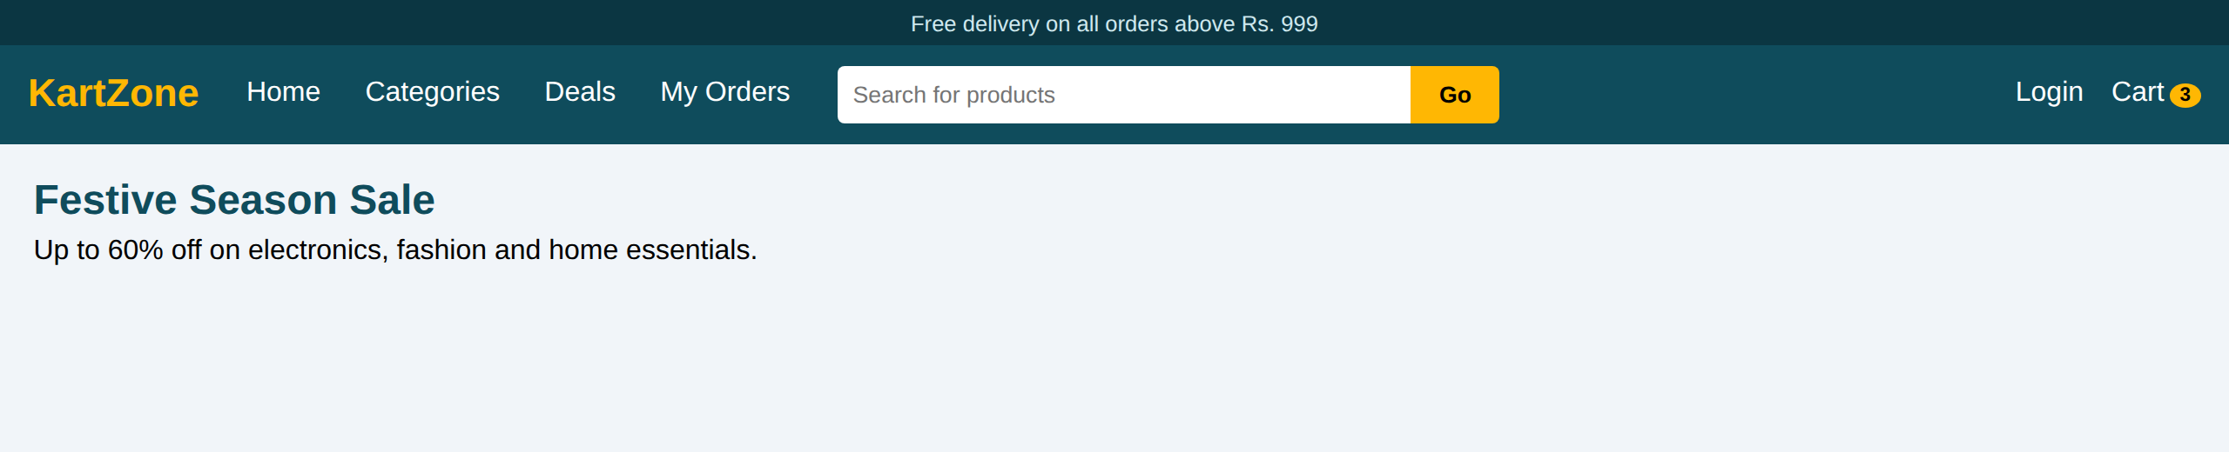
Figure 1.1: Desktop view (1280px)
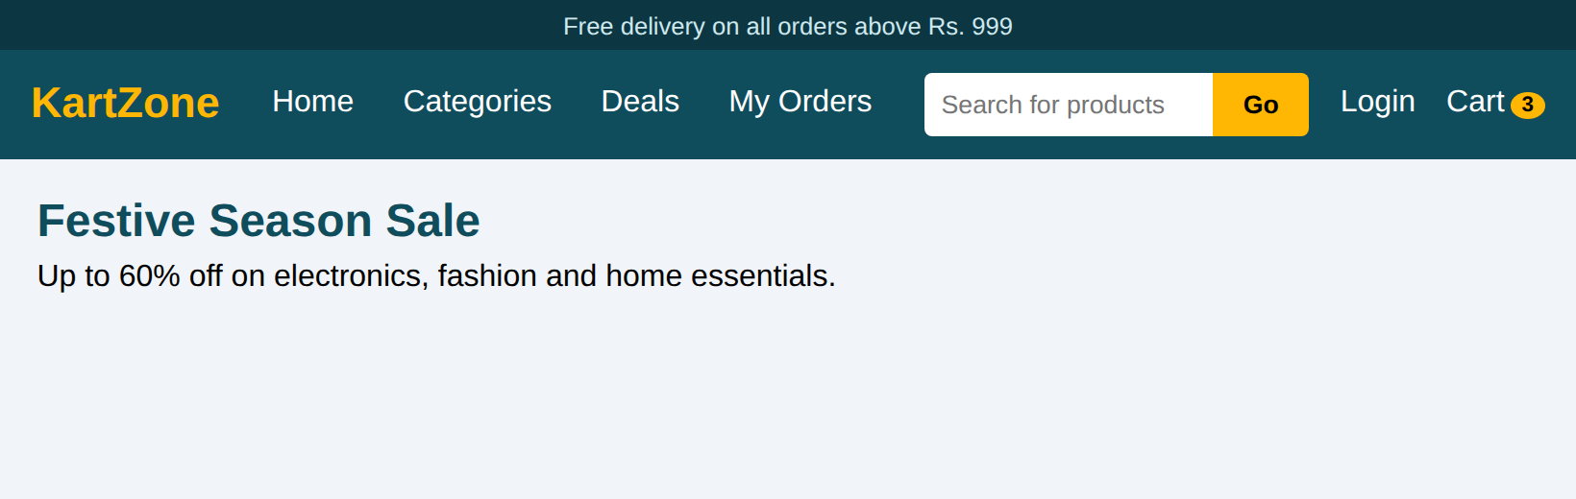
Figure 1.2: Tablet view (820px)
  Figure 1.3: Mobile – menu closed | 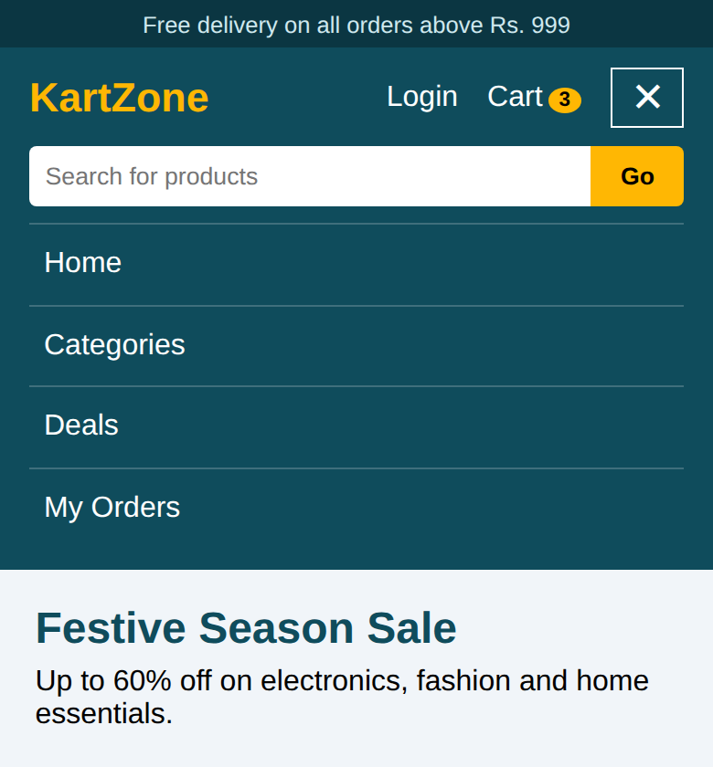  Figure 1.4: Mobile – menu open

(d) Usability evaluation and improvements
Criterion | Evaluation of the design
Findability | Search and cart stay visible on every device, so the two most important shopping actions are always one tap away.
Touch friendliness | Menu links are at least 44px high on mobile, which avoids mis-taps.
Consistency | The same items appear on all devices; only the layout changes.
Feedback | Hover and keyboard focus change the link colour; the hamburger icon changes to ✕ when open.
Accessibility | aria-expanded, aria-controls and aria-label describe the toggle; links can be reached with the Tab key.

Suggested improvements:
- Add category drop-downs (mega menu) and search auto-suggestions to reduce the number of clicks.
- Add a wishlist icon and a mini-cart preview that shows products without leaving the page.
- Close the mobile menu automatically when a link is selected or when the user taps outside it.
- Add a visible focus outline for all controls and test colour contrast with an accessibility checker.
- Use a sticky bottom bar (Home, Categories, Cart) on phones for easier one-hand use.
Question 2: Product Hover Effect
An e-commerce website wants to enhance user interaction through visual effects on product items. (a) Identify suitable CSS properties for hover effects. (b) Suggest appropriate CSS animation or transition for product interaction. (c) Design a hover effect for a product card. (d) Evaluate performance and user experience considerations.
SOLUTION:
(a) Suitable CSS properties for hover effects
Property | Effect on the product card
transform (translateY, scale) | Lifts the card and zooms the product image without disturbing neighbouring elements.
box-shadow | A deeper shadow gives the impression that the card rises above the page.
opacity | Fades items such as overlays in and out.
filter (brightness, grayscale) | Changes the look of the image on hover.
background-color / color | Gives colour feedback on buttons (dark to amber).
letter-spacing | A small change that adds emphasis to the button text.
cursor: pointer | Shows that the item can be clicked.

(b) Suitable CSS transition or animation
A CSS transition is the best choice for hover interaction because it only needs two states (normal and hover) and automatically reverses when the pointer leaves. A @keyframes animation is better for effects that run on their own; therefore it is used here only for the small pulsing discount tag. The transitions used are:
- Card: transition: transform .3s ease, box-shadow .3s ease (quick and responsive).
- Image: transition: transform .5s ease (slower zoom looks smoother).
- Quick View panel: slides up with transform .3s ease.
- Button: transition: background .3s ease, letter-spacing .3s ease.
- Discount tag: @keyframes pulse that scales the tag between 100% and 110%.
Durations between 0.2s and 0.5s are used because shorter feels instant and longer feels slow.
(c) Hover effect for a product card
When the user hovers over (or tabs to) a card: (1) the card moves up by 8px and its shadow becomes deeper, (2) the product picture zooms in by 12% inside its frame, (3) a “Quick View” strip slides up from the bottom of the picture, and (4) the Add to Cart button changes from dark grey to amber.
HTML & CSS CODE:
<!DOCTYPE html>
<html lang="en">
<head>
<meta charset="UTF-8">
<meta name="viewport" content="width=device-width, initial-scale=1.0">
<title>Product Card Hover Effect</title>
<style>
* { box-sizing:border-box; margin:0; padding:0; }
body { font-family:Arial,sans-serif; background:#f3f4f6; padding:2rem 1rem; }
h2 { text-align:center; color:#1f2937; margin-bottom:1.5rem; }
.grid { display:flex; flex-wrap:wrap; gap:24px; justify-content:center; }
.card { width:230px; background:#fff; border-radius:12px; overflow:hidden;
box-shadow:0 2px 6px rgba(0,0,0,.15);
transition:transform .3s ease, box-shadow .3s ease; }
.card:hover, .card:focus-within { transform:translateY(-8px);
box-shadow:0 14px 28px rgba(0,0,0,.25); }
.media { position:relative; height:160px; overflow:hidden; }
.pic { height:100%; transition:transform .5s ease; }
.pic::after { content:""; position:absolute; left:50%; top:50%; width:70px;
height:70px; margin:-35px 0 0 -35px; border-radius:50%;
background:rgba(255,255,255,.35); }
.p1 { background:linear-gradient(135deg,#38bdf8,#1e3a8a); }
.p2 { background:linear-gradient(135deg,#f472b6,#7c3aed); }
.p3 { background:linear-gradient(135deg,#34d399,#065f46); }
.card:hover .pic { transform:scale(1.12); }
.tag { position:absolute; top:10px; left:10px; z-index:2; background:#ef4444;
color:#fff; font-size:.75rem; padding:3px 8px; border-radius:4px;
animation:pulse 1.6s infinite; }
@keyframes pulse { 50% { transform:scale(1.1); } }
.quick { position:absolute; left:0; right:0; bottom:0; z-index:2; padding:9px;
text-align:center; color:#fff; background:rgba(0,0,0,.65);
transform:translateY(100%); transition:transform .3s ease; }
.card:hover .quick, .card:focus-within .quick { transform:translateY(0); }
.info { padding:14px; text-align:center; }
.info h3 { font-size:1.05rem; color:#111827; }
.rating { color:#f59e0b; font-size:.9rem; margin:4px 0; }
.price { font-weight:bold; color:#111827; }
.price del { color:#9ca3af; font-weight:normal; margin-left:6px; }
.add { margin-top:10px; width:100%; padding:9px; border:0; border-radius:6px;
background:#1f2937; color:#fff; cursor:pointer;
transition:background .3s ease, letter-spacing .3s ease; }
.card:hover .add { background:#f59e0b; color:#111827; letter-spacing:.5px; }
@media (hover:none) { .quick { transform:none; } }
@media (prefers-reduced-motion:reduce) {
.card, .pic, .quick, .add, .tag { transition:none; animation:none; }
}
</style>
</head>
<body>
<h2>Trending Products</h2>
<div class="grid">
<article class="card" tabindex="0">
<div class="media"><span class="tag">-20%</span><div class="pic p1"></div>
<div class="quick">Quick View</div></div>
<div class="info"><h3>Wireless Headphones</h3>
<p class="rating">&#9733;&#9733;&#9733;&#9733;&#9734; (128)</p>
<p class="price">Rs. 1,999 <del>Rs. 2,499</del></p>
<button class="add">Add to Cart</button></div>
</article>
<article class="card" tabindex="0">
<div class="media"><span class="tag">NEW</span><div class="pic p2"></div>
<div class="quick">Quick View</div></div>
<div class="info"><h3>Smart Watch</h3>
<p class="rating">&#9733;&#9733;&#9733;&#9733;&#9733; (86)</p>
<p class="price">Rs. 3,499 <del>Rs. 4,299</del></p>
<button class="add">Add to Cart</button></div>
</article>
<article class="card" tabindex="0">
<div class="media"><span class="tag">-35%</span><div class="pic p3"></div>
<div class="quick">Quick View</div></div>
<div class="info"><h3>Travel Backpack</h3>
<p class="rating">&#9733;&#9733;&#9733;&#9734;&#9734; (54)</p>
<p class="price">Rs. 899 <del>Rs. 1,399</del></p>
<button class="add">Add to Cart</button></div>
</article>
</div>
</body>
</html>

OUTPUT:
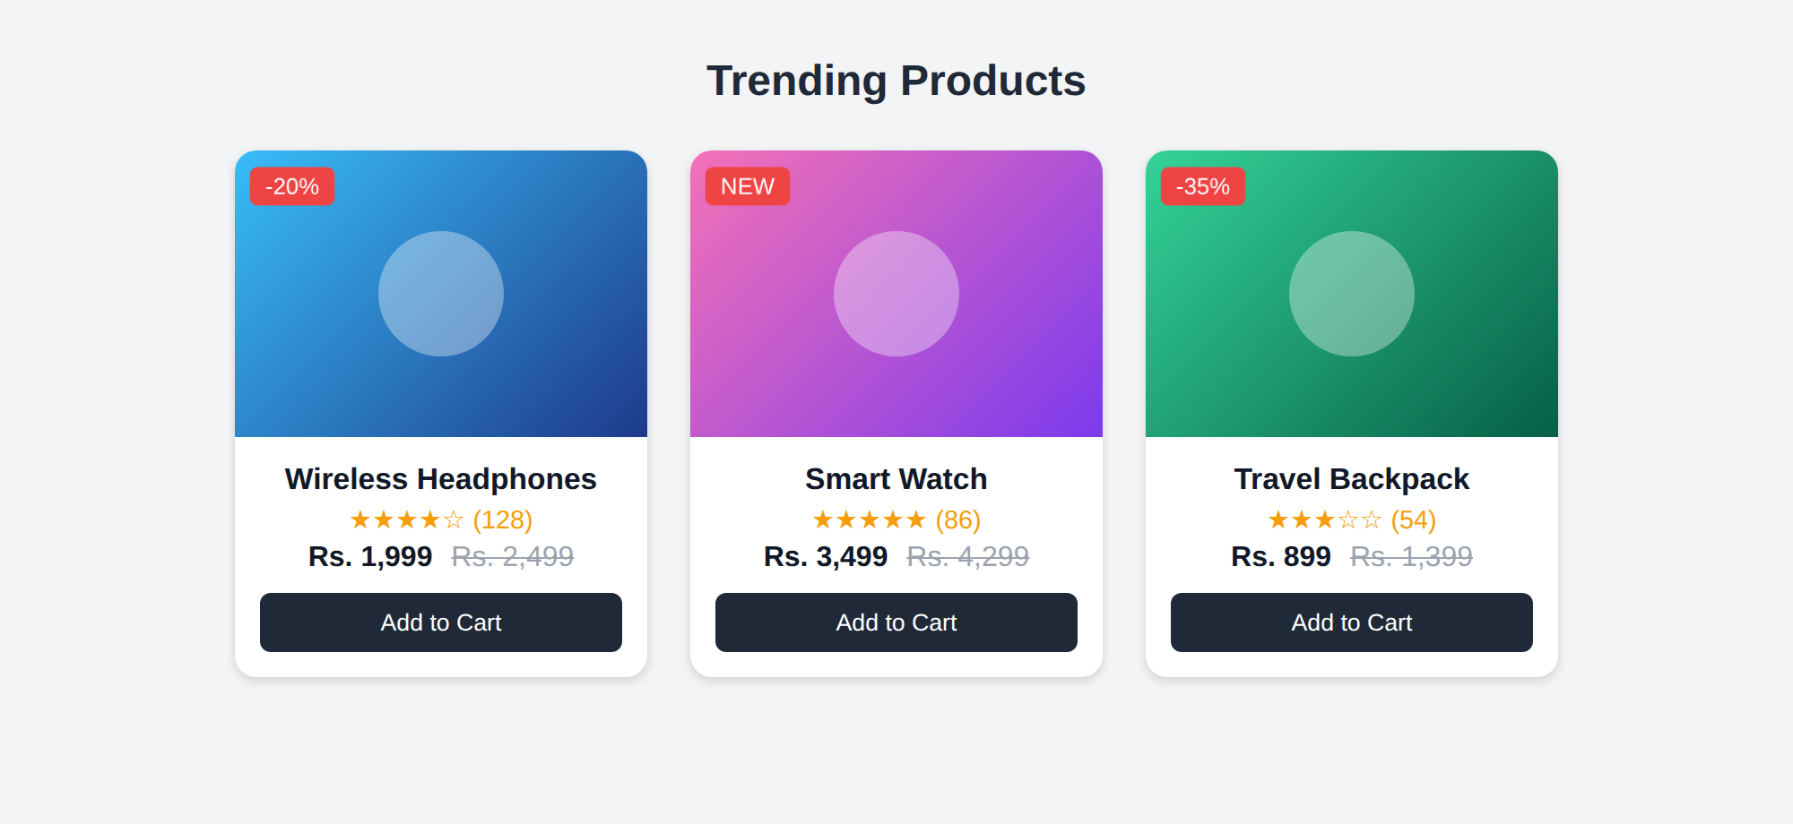
Figure 2.1: Product cards in the normal state
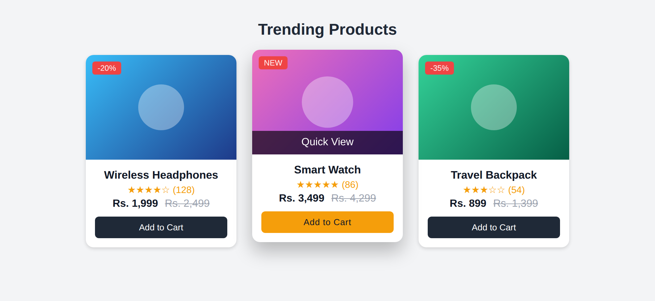
Figure 2.2: Hover on “Smart Watch” – lifted card, zoomed image, Quick View strip and amber button
(d) Performance and user experience considerations
Aspect | Evaluation
Performance | transform and opacity are handled by the GPU compositor and do not cause layout recalculation, so the animation stays smooth at 60 frames per second. Properties such as width, height, top and margin are avoided because they force reflow.
Touch devices | Phones have no hover. The rule @media (hover: none) keeps the Quick View strip permanently visible so that no information is hidden.
Keyboard users | :focus-within and tabindex=“0” give the same effect when the card is reached with the Tab key.
Motion sensitivity | @media (prefers-reduced-motion: reduce) switches all transitions and animation off for users who prefer less motion.
User experience | The effects are short and subtle, they give clear feedback, and the price and rating always remain readable.

Suggested improvements:
- Use will-change: transform only on the hovered card, not on every card.
- Use real optimised product images (WebP, lazy loading) and a second image on hover.
- Add a wishlist (heart) button that fades in together with the Quick View strip.
Question 3: Layout Selection (Flexbox vs Grid)
A dashboard layout needs to be designed for a web application. (a) Identify layout requirements of a dashboard (rows, columns, alignment). (b) Compare Flexbox and Grid based on layout needs. (c) Choose the most suitable layout technique and justify your choice. (d) Evaluate the scalability and responsiveness of the chosen approach.
SOLUTION:
(a) Layout requirements of a dashboard
Requirement | Description
Rows | A header row at the top, then rows for key figures (KPI cards), charts and tables.
Columns | A fixed-width sidebar for navigation, a flexible main area and a narrow column for recent activity.
Spanning | The header must span all columns; the sidebar must span several rows; the chart must be wider than a KPI card.
Alignment | Cards must align in both directions with equal gaps; inside a card, the title and the user name are placed at opposite ends.
Responsiveness | On phones the sidebar becomes a menu row and all blocks stack in one column.

(b) Comparison of Flexbox and Grid
Feature | Flexbox | CSS Grid
Dimension | One-dimensional (row or column) | Two-dimensional (rows and columns together)
Approach | Content-first: items decide their size | Layout-first: the grid is defined and items are placed in it
Spanning cells | Not possible in both directions | grid-area, grid-column and grid-row span cells easily
Alignment | Strong along one main axis | Aligns in both axes at the same time
Responsive tools | flex-wrap, flex-basis | grid-template-areas, repeat(auto-fit, minmax())
Best suited for | Navbars, toolbars, button groups, content inside cards | Full page layouts, dashboards, galleries

(c) Chosen technique and justification
CSS Grid is chosen for the overall dashboard structure, and Flexbox for the small components inside it.
- A dashboard is a two-dimensional layout: the header spans three columns and the sidebar spans three rows. Grid does this directly with grid-template-areas.
- The page structure is readable: the named areas in the CSS look like a drawing of the page.
- The layout for each screen size is changed only by redefining the template in a media query; the HTML is not touched.
- Flexbox is used where only one direction is needed: the header bar, the sidebar links, the bar chart and the status pills. The KPI cards use a nested Grid with repeat(auto-fit, minmax(150px, 1fr)) so the number of cards per row adjusts automatically.
HTML & CSS CODE:
<!DOCTYPE html>
<html lang="en">
<head>
<meta charset="UTF-8">
<meta name="viewport" content="width=device-width, initial-scale=1.0">
<title>Admin Dashboard Layout</title>
<style>
:root { --navy:#1e293b; --blue:#2563eb; --gap:14px; }
* { box-sizing:border-box; margin:0; padding:0; }
body { font-family:Arial,sans-serif; background:#f1f5f9; color:#1e293b; }
.dash { display:grid; gap:var(--gap); padding:var(--gap); align-content:start;
grid-template-columns:minmax(0,1fr);
grid-template-areas:"hdr" "side" "kpis" "chart" "orders" "act"; }
.box { background:#fff; border-radius:10px; padding:16px;
box-shadow:0 1px 4px rgba(0,0,0,.12); }
.hdr { grid-area:hdr; display:flex; justify-content:space-between;
align-items:center; background:var(--navy); color:#fff; }
.side { grid-area:side; display:flex; flex-wrap:wrap; gap:8px; }
.side a { flex:1 1 auto; text-align:center; padding:8px 12px; border-radius:6px;
color:#334155; text-decoration:none; background:#e2e8f0; }
.side a.on { background:var(--blue); color:#fff; }
.kpis { grid-area:kpis; display:grid; gap:var(--gap);
grid-template-columns:repeat(auto-fit,minmax(150px,1fr)); }
.kpi { background:#fff; border-radius:10px; padding:14px;
border-left:5px solid var(--blue); box-shadow:0 1px 4px rgba(0,0,0,.12); }
.kpi small { color:#64748b; }
.kpi strong { display:block; font-size:1.5rem; }
.chart { grid-area:chart; }
.bars { display:flex; align-items:flex-end; gap:10px; height:150px;
margin:14px 0 26px; }
.bars span { flex:1; height:var(--h); background:var(--blue);
border-radius:4px 4px 0 0; position:relative; }
.bars span::after { content:attr(data-m); position:absolute; bottom:-22px;
left:0; right:0; text-align:center; font-size:.75rem; color:#64748b; }
.orders { grid-area:orders; overflow-x:auto; }
table { width:100%; border-collapse:collapse; font-size:.9rem; margin-top:8px; }
th, td { text-align:left; padding:8px; border-bottom:1px solid #e2e8f0; }
.pill { padding:2px 8px; border-radius:10px; font-size:.8rem; }
.ok { background:#dcfce7; color:#166534; }
.wait { background:#fef9c3; color:#854d0e; }
.act { grid-area:act; }
.act li { list-style:none; padding:8px 0; border-bottom:1px solid #e2e8f0;
font-size:.9rem; }
@media (min-width:640px) {
.dash { grid-template-columns:1fr 1fr;
grid-template-areas:"hdr hdr" "side side" "kpis kpis"
"chart chart" "orders act"; }
}
@media (min-width:992px) {
.dash { grid-template-columns:190px minmax(0,1fr) 290px;
grid-template-areas:"hdr hdr hdr" "side kpis kpis"
"side chart act" "side orders act"; }
.side { flex-direction:column; flex-wrap:nowrap; align-content:flex-start; }
.side a { flex:0 0 auto; text-align:left; }
}
</style>
</head>
<body>
<div class="dash">
<header class="box hdr"><strong>Sales Dashboard</strong><span>Admin</span></header>
<aside class="box side">
<a class="on" href="#">Overview</a><a href="#">Orders</a>
<a href="#">Products</a><a href="#">Customers</a><a href="#">Reports</a>
</aside>
<section class="kpis">
<div class="kpi"><small>Orders</small><strong>1,254</strong></div>
<div class="kpi"><small>Revenue</small><strong>Rs. 8.4L</strong></div>
<div class="kpi"><small>Customers</small><strong>312</strong></div>
<div class="kpi"><small>Returns</small><strong>2.1%</strong></div>
</section>
<section class="box chart"><strong>Monthly Sales</strong>
<div class="bars">
<span style="--h:45%" data-m="Jan"></span><span style="--h:60%" data-m="Feb"></span>
<span style="--h:52%" data-m="Mar"></span><span style="--h:75%" data-m="Apr"></span>
<span style="--h:68%" data-m="May"></span><span style="--h:90%" data-m="Jun"></span>
</div>
</section>
<section class="box orders"><strong>Recent Orders</strong>
<table>
<tr><th>ID</th><th>Customer</th><th>Amount</th><th>Status</th></tr>
<tr><td>#1001</td><td>Arun</td><td>Rs. 1,999</td><td><span class="pill ok">Delivered</span></td></tr>
<tr><td>#1002</td><td>Meena</td><td>Rs. 3,499</td><td><span class="pill wait">Shipped</span></td></tr>
<tr><td>#1003</td><td>Rahul</td><td>Rs. 899</td><td><span class="pill ok">Delivered</span></td></tr>
</table>
</section>
<section class="box act"><strong>Recent Activity</strong>
<ul><li>New order #1003 received</li><li>Stock low: Smart Watch</li>
<li>Customer Meena left a review</li><li>Refund processed for #0998</li></ul>
</section>
</div>
</body>
</html>

OUTPUT:
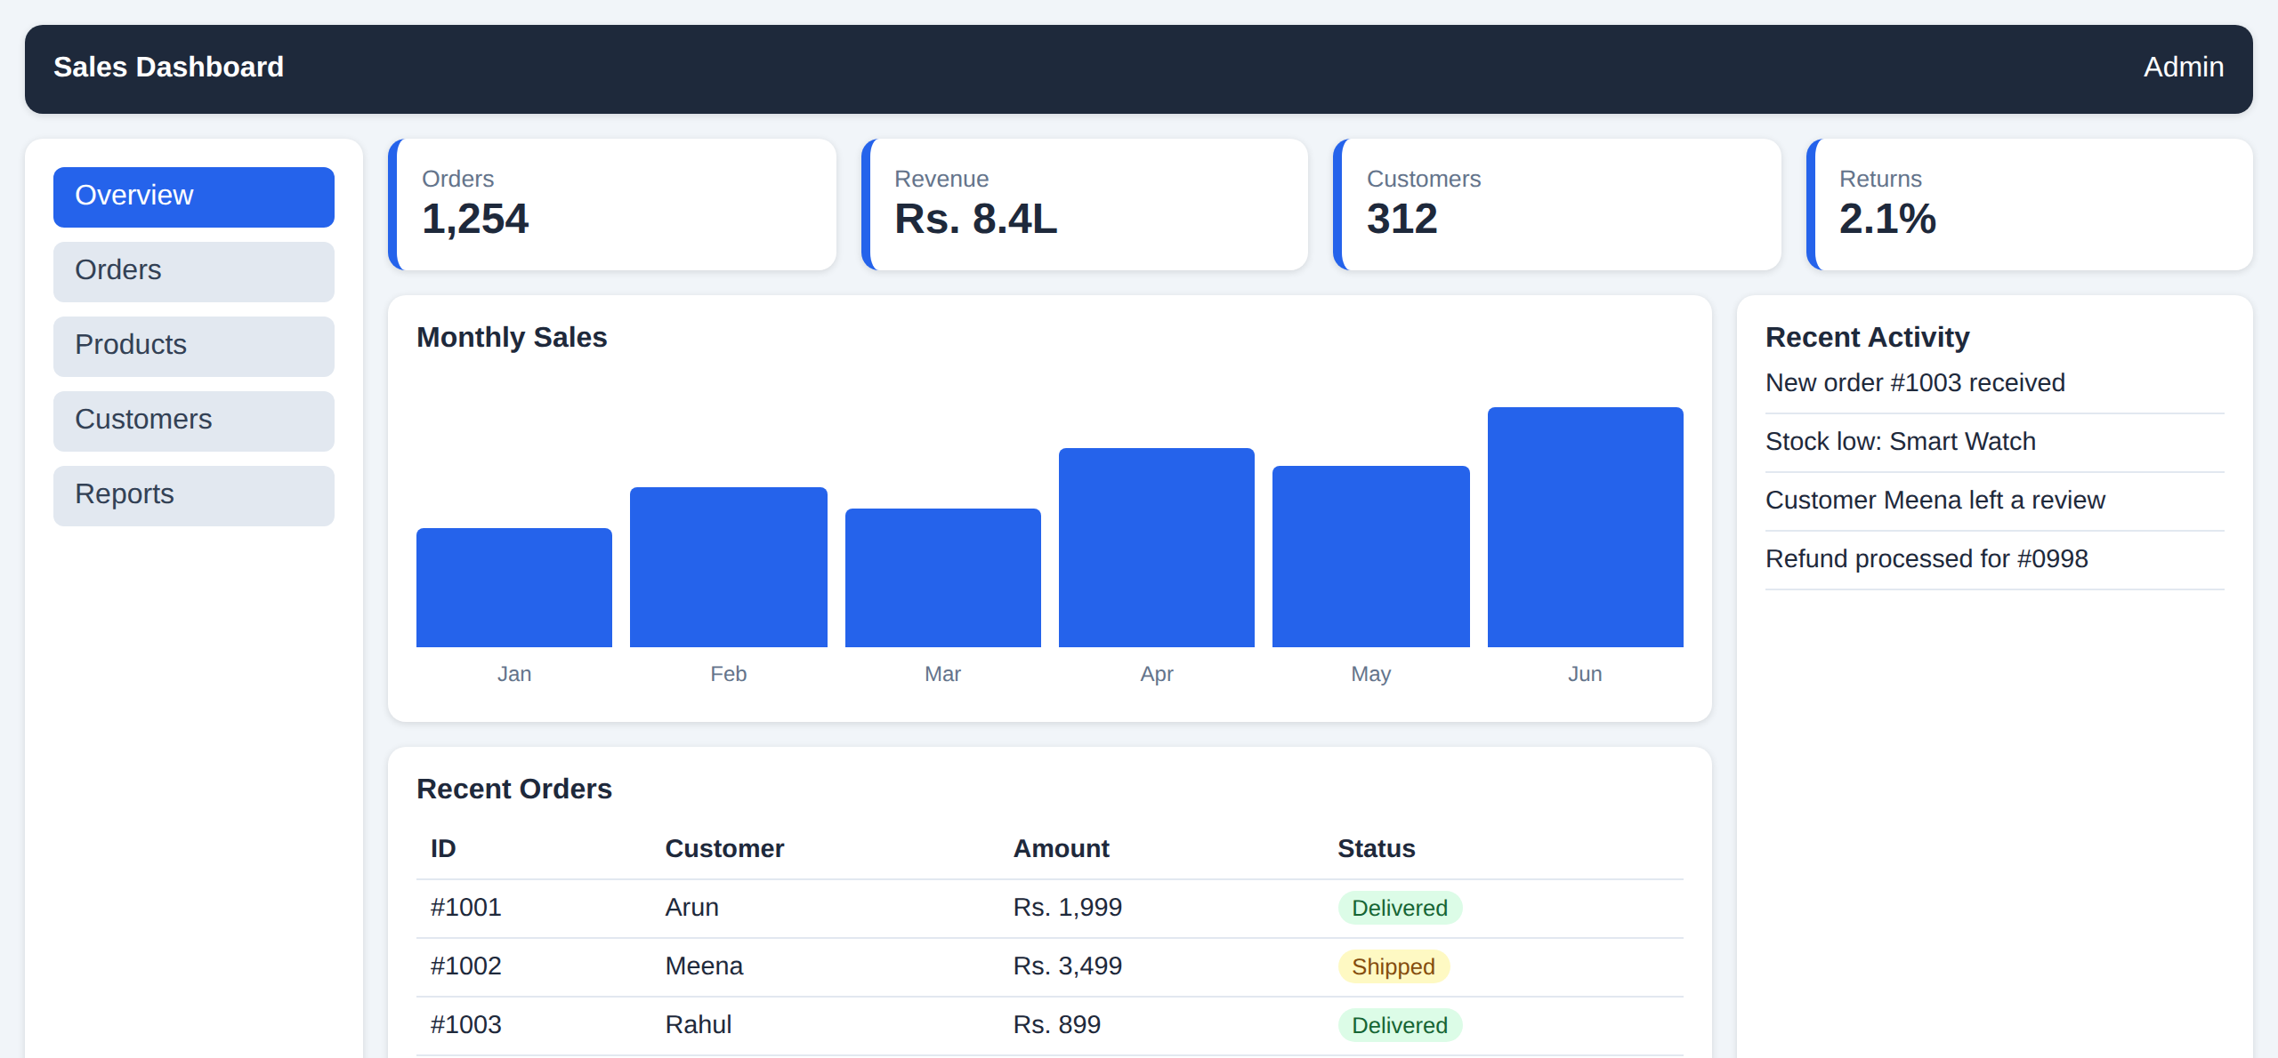
Figure 3.1: Desktop (1280px) – three columns: sidebar, main area, activity
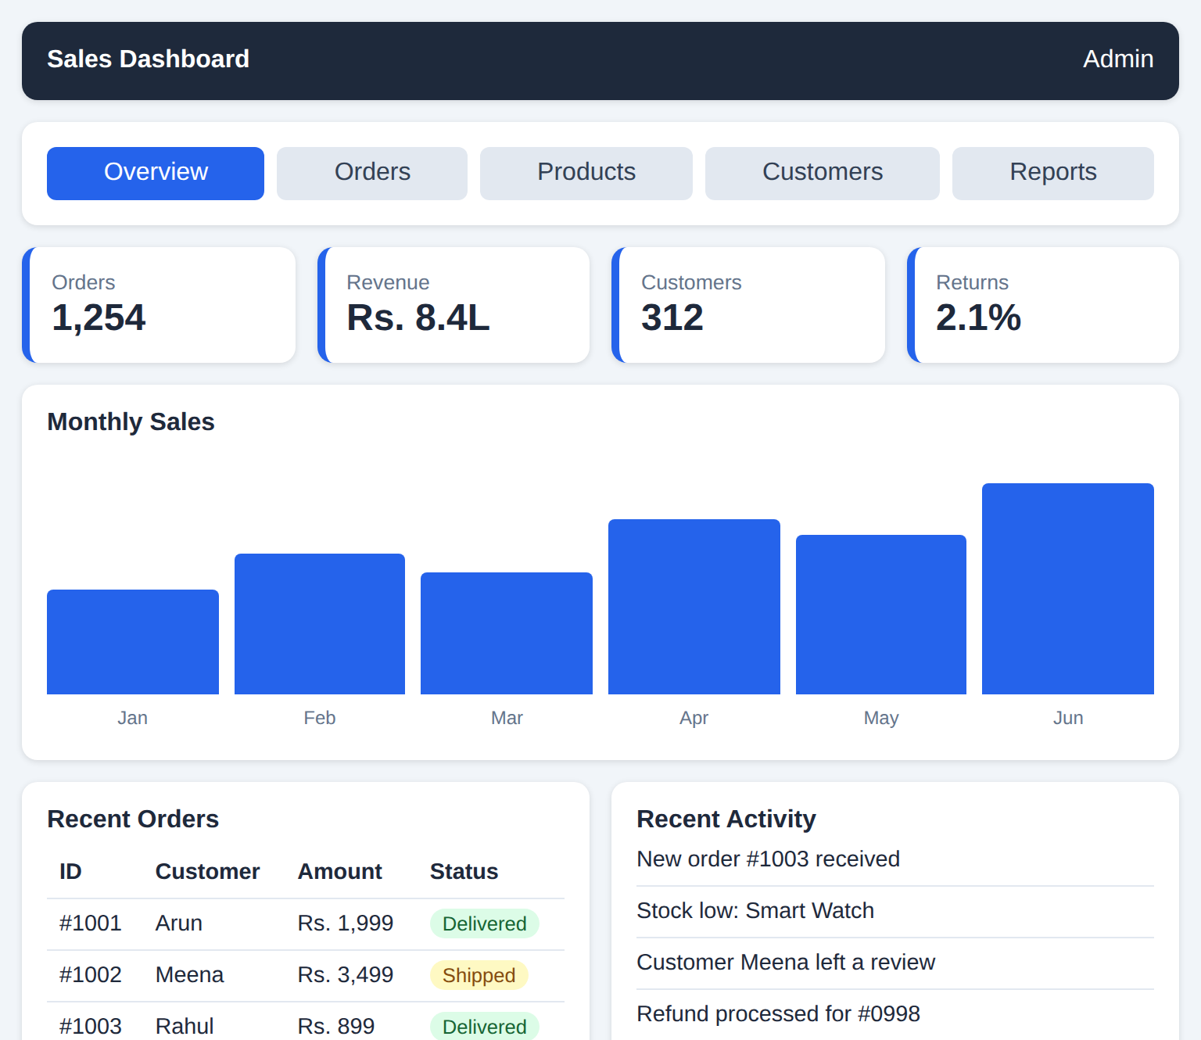
Figure 3.2: Tablet (768px) – two columns, sidebar becomes a row
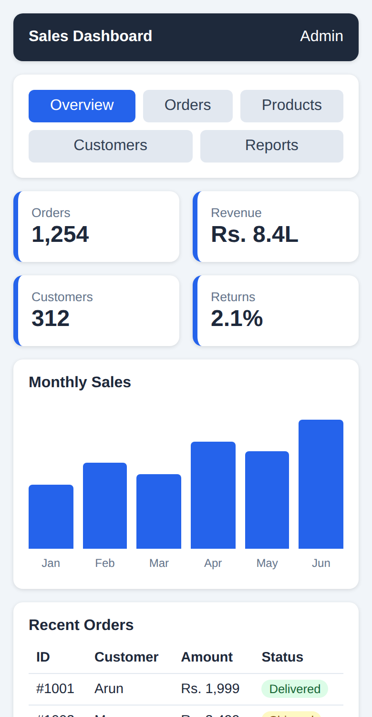
Figure 3.3: Mobile (390px) – single column (top part)
(d) Scalability and responsiveness
Aspect | Evaluation
Scalability | A new widget needs only one new grid-area name and one extra row in the template; existing blocks are not changed.
Responsiveness | One column below 640px, two columns from 640px and three columns from 992px, as shown in the output. minmax(0, 1fr) prevents wide tables from breaking the layout.
Maintainability | Named areas, the gap variable and colour variables keep the code short and easy to read.
Data handling | The orders table is placed in a container with overflow-x: auto, so it scrolls instead of overflowing on small screens.

Suggested improvements:
- Add a collapsible sidebar and a dark theme using CSS variables.
- Replace the CSS bars by a chart library (for example Chart.js) fed with live data.
- Use container queries so each widget adapts to the space it is given, not only to the screen size.
Question 4: Mobile-First Blog Layout
A blog page must be designed following a mobile-first approach. (a) Identify key sections of a blog layout. (b) Design a mobile-first layout using CSS. (c) Demonstrate how the layout scales for larger screens using media queries. (d) Evaluate accessibility and readability of the design.
SOLUTION:
(a) Key sections of a blog layout
Section | Content | HTML element
Header | Blog name and the main navigation | <header>, <nav>
Featured post | The latest or most important article, shown larger | <article>
Post list | Cards with title, date, author and a short summary | <main>, <article>
Sidebar | About the author, categories, popular posts | <aside>
Footer | Copyright, contact and social links | <footer>
Skip link | Lets keyboard users jump directly to the content | <a href="#content">

(b) Mobile-first layout using CSS
In the mobile-first approach the default CSS (outside any media query) styles the phone layout: one column, full-width cards, a 1.05rem font and a line height of 1.7. Larger layouts are added later with min-width media queries, so a phone loads only the simple rules. Semantic elements give the page a clear structure for search engines and screen readers.
HTML & CSS CODE:
<!DOCTYPE html>
<html lang="en">
<head>
<meta charset="UTF-8">
<meta name="viewport" content="width=device-width, initial-scale=1.0">
<title>Mobile-First Blog - Web Notes</title>
<style>
:root { --ink:#1f2933; --brand:#6d28d9; --bg:#f6f4fb; }
* { box-sizing:border-box; margin:0; padding:0; }
body { font-family:Georgia,serif; font-size:1.05rem; line-height:1.7;
color:var(--ink); background:var(--bg); }
.skip { position:absolute; left:-999px; }
.skip:focus { left:8px; top:8px; background:#fff; padding:6px; z-index:5; }
a:focus-visible { outline:3px solid #f59e0b; outline-offset:2px; }
header { background:var(--brand); color:#fff; padding:1rem; text-align:center; }
header h1 { font-size:1.6rem; }
nav ul { list-style:none; display:flex; flex-wrap:wrap; justify-content:center;
gap:.2rem 1rem; margin-top:.4rem; }
nav a { color:#fff; display:inline-block; padding:.4rem .2rem; }
.wrap { padding:1rem; }
.posts { display:grid; gap:1rem; }
.card { background:#fff; border-radius:8px; overflow:hidden;
box-shadow:0 1px 4px rgba(0,0,0,.15); }
.thumb { height:120px; }
.t1 { background:linear-gradient(135deg,#a78bfa,#4c1d95); }
.t2 { background:linear-gradient(135deg,#60a5fa,#1e3a8a); }
.t3 { background:linear-gradient(135deg,#34d399,#064e3b); }
.t4 { background:linear-gradient(135deg,#fbbf24,#92400e); }
.t5 { background:linear-gradient(135deg,#f472b6,#831843); }
.body { padding:1rem; }
.body h2 { font-size:1.25rem; line-height:1.3; margin-bottom:.3rem; }
.meta { font-size:.85rem; color:#52606d; margin-bottom:.4rem; }
aside .box { background:#fff; border-radius:8px; padding:1rem; margin-top:1rem; }
aside h3 { margin-bottom:.3rem; }
aside ul { padding-left:1.2rem; }
footer { background:#2e1065; color:#fff; text-align:center; padding:1rem;
margin-top:1rem; }
@media (min-width:600px) {
.posts { grid-template-columns:repeat(2,1fr); }
.featured { grid-column:1 / -1; }
.featured .thumb { height:170px; }
}
@media (min-width:992px) {
header h1 { font-size:2.2rem; }
.wrap { display:grid; grid-template-columns:minmax(0,1fr) 290px; gap:1.5rem;
max-width:1100px; margin:0 auto; }
aside .box { margin-top:0; margin-bottom:1rem; }
}
</style>
</head>
<body>
<a class="skip" href="#content">Skip to content</a>
<header>
<h1>Web Notes</h1>
<nav aria-label="Primary">
<ul><li><a href="#">Home</a></li><li><a href="#">Tutorials</a></li>
<li><a href="#">About</a></li><li><a href="#">Contact</a></li></ul>
</nav>
</header>
<div class="wrap">
<main id="content" class="posts">
<article class="card featured">
<div class="thumb t1" role="img" aria-label="Purple gradient banner"></div>
<div class="body"><h2>CSS Grid in Ten Minutes</h2>
<p class="meta">20 Oct 2026 | by Siva Prasad</p>
<p>Rows, columns and named areas explained with one small example.</p></div>
</article>
<article class="card">
<div class="thumb t2" role="img" aria-label="Blue gradient banner"></div>
<div class="body"><h2>Flexbox or Grid?</h2>
<p class="meta">14 Oct 2026 | by Siva Prasad</p>
<p>Choose the right layout tool for every job.</p></div>
</article>
<article class="card">
<div class="thumb t3" role="img" aria-label="Green gradient banner"></div>
<div class="body"><h2>Why Mobile First?</h2>
<p class="meta">9 Oct 2026 | by Siva Prasad</p>
<p>Start small, then enhance for larger screens.</p></div>
</article>
<article class="card">
<div class="thumb t4" role="img" aria-label="Orange gradient banner"></div>
<div class="body"><h2>JavaScript Events</h2>
<p class="meta">2 Oct 2026 | by Siva Prasad</p>
<p>Connect user actions to page behaviour.</p></div>
</article>
<article class="card">
<div class="thumb t5" role="img" aria-label="Pink gradient banner"></div>
<div class="body"><h2>Accessible Forms</h2>
<p class="meta">25 Sep 2026 | by Siva Prasad</p>
<p>Labels and contrast help every visitor.</p></div>
</article>
</main>
<aside aria-label="Sidebar">
<div class="box"><h3>About</h3><p>Short notes from my internet programming course.</p></div>
<div class="box"><h3>Categories</h3>
<ul><li>HTML</li><li>CSS</li><li>JavaScript</li></ul></div>
</aside>
</div>
<footer><p>&copy; 2026 Web Notes</p></footer>
</body>
</html>

(c) Scaling to larger screens with media queries
Screen | Breakpoint | Layout
Mobile | default | All sections are stacked in a single column; the sidebar appears below the posts.
Tablet | min-width: 600px | Posts are shown in a 2-column grid; the first (featured) post spans both columns using grid-column: 1 / -1.
Desktop | min-width: 992px | The page becomes a two-column grid (posts and a 290px sidebar), limited to a maximum width of 1100px; the main heading becomes larger.
OUTPUT:

Figure 4.1: Mobile (390px) – one column (top part)
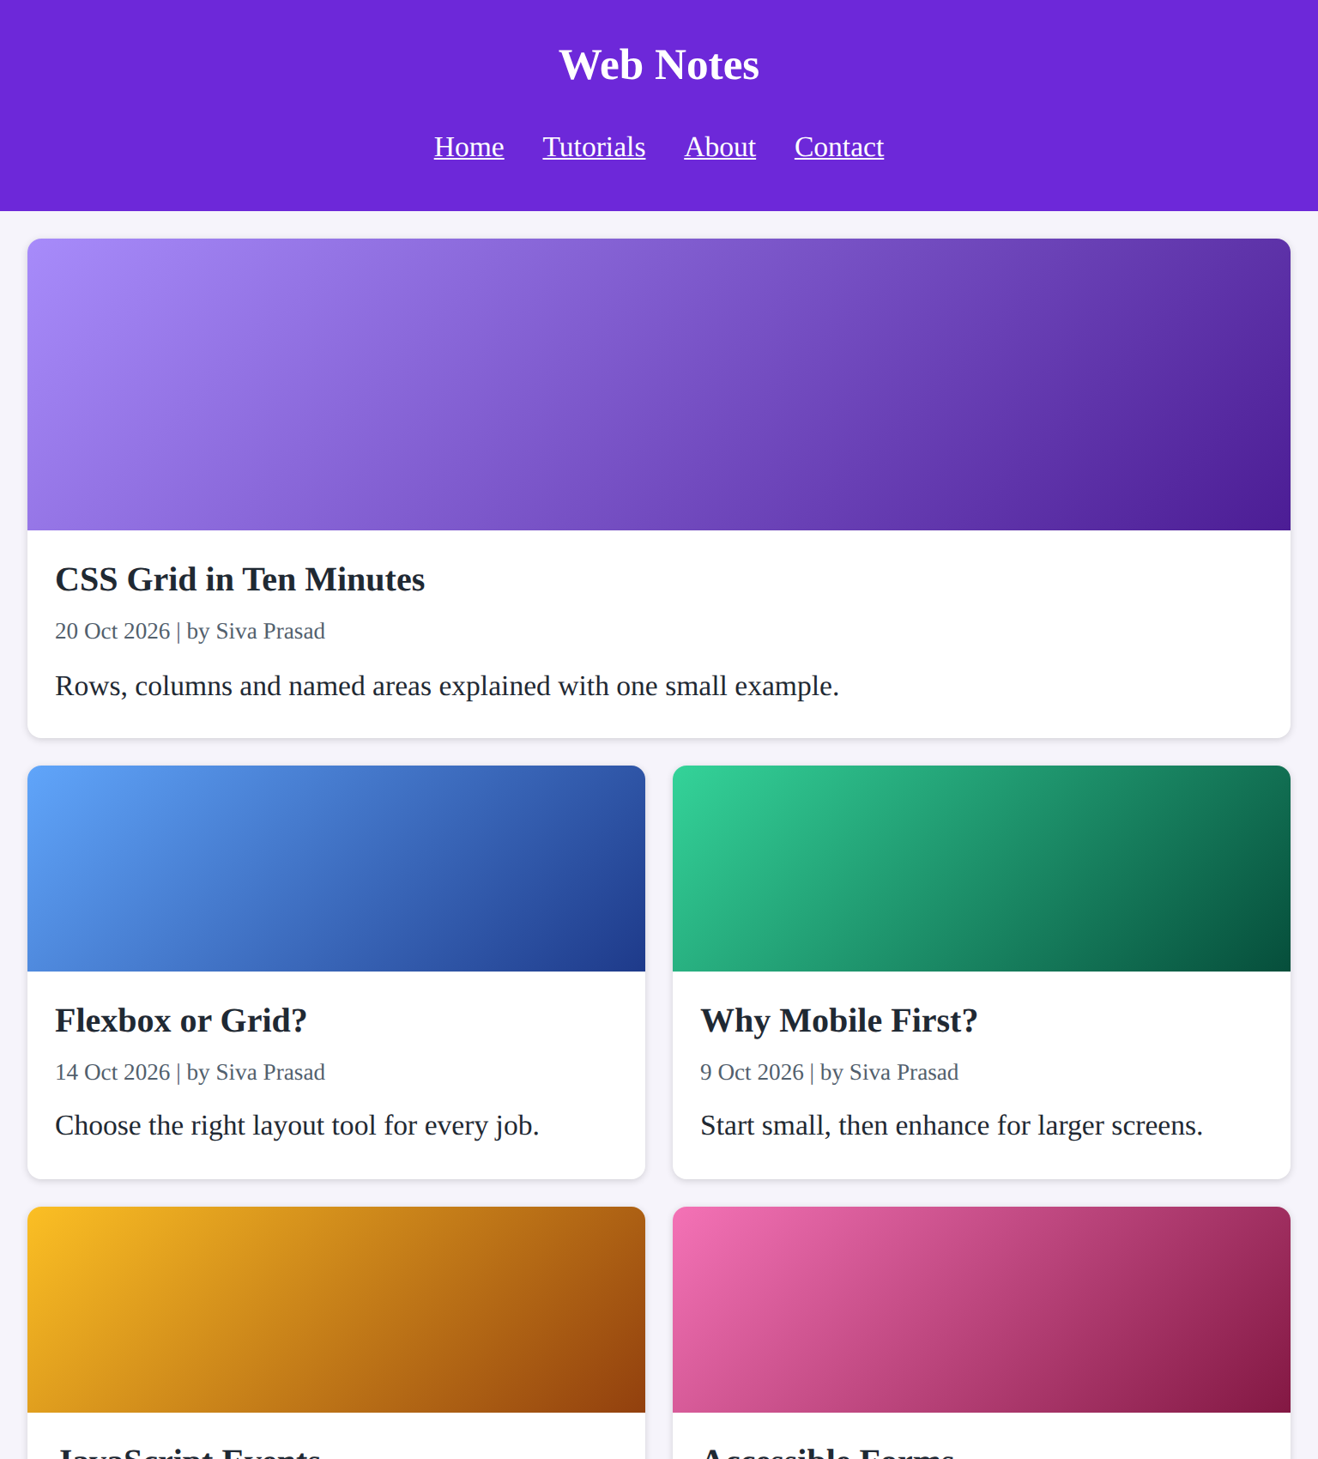
Figure 4.2: Tablet (768px) – two-column post grid (top part)
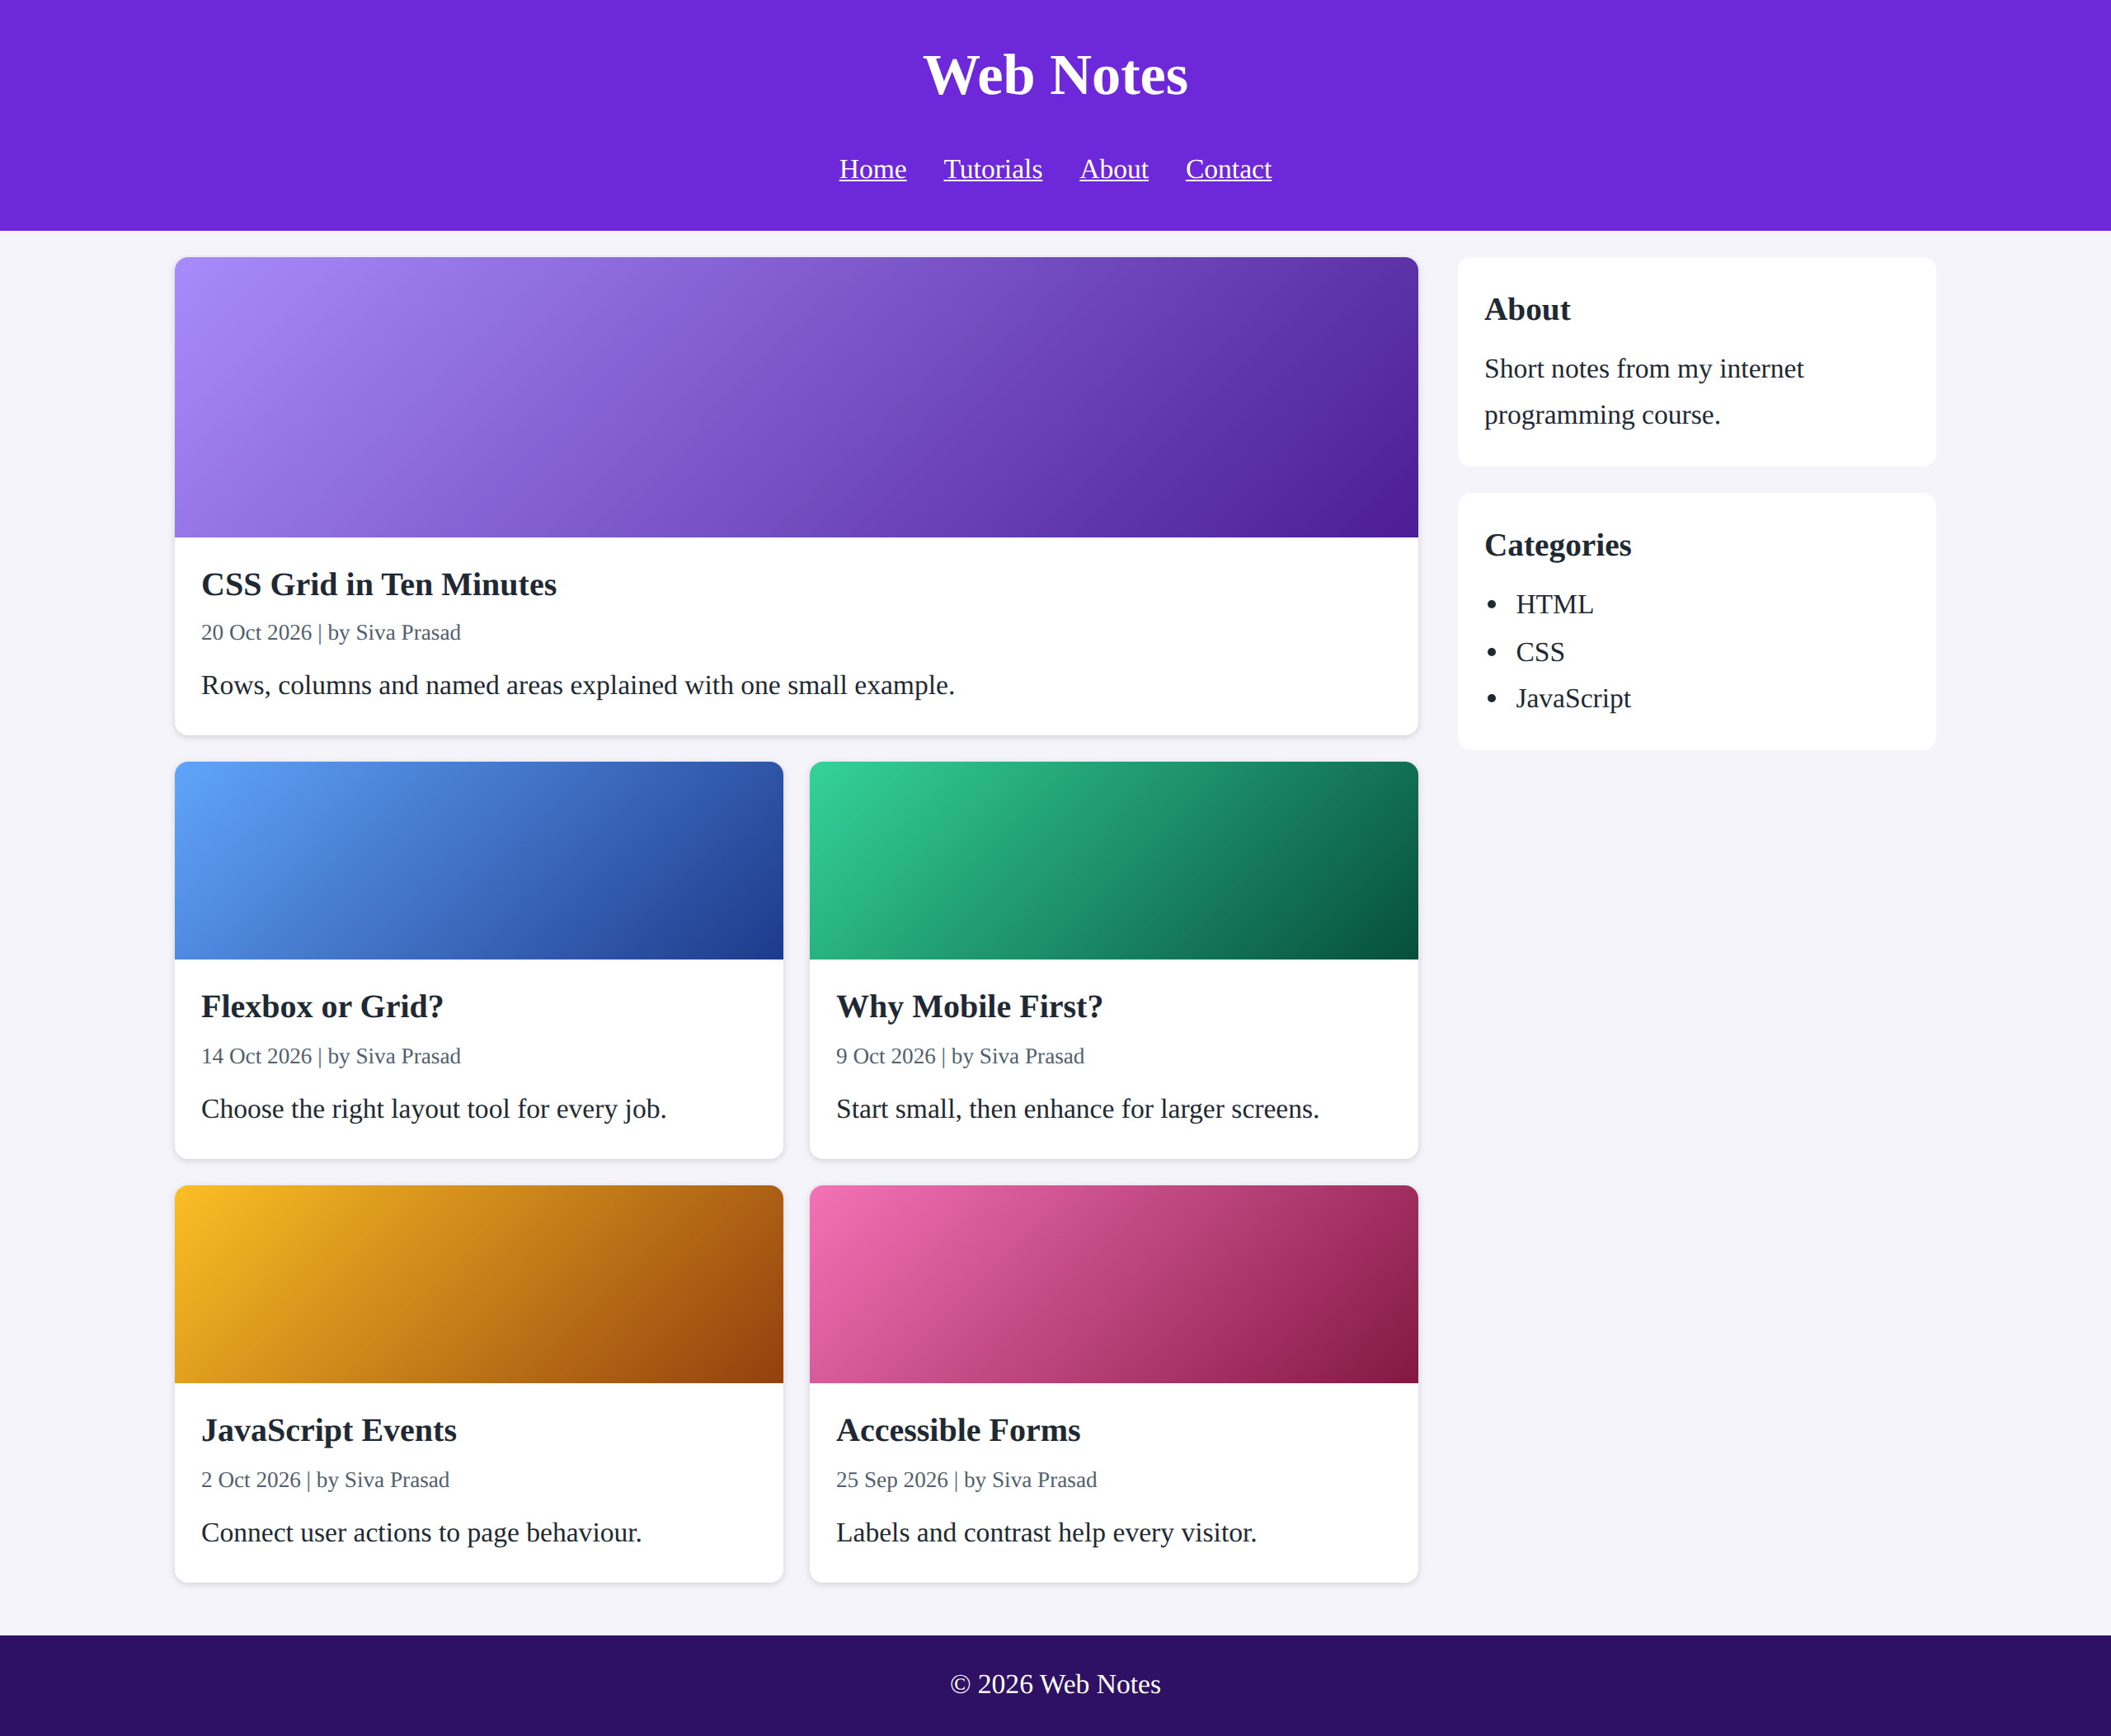
Figure 4.3: Desktop (1280px) – posts with sidebar
(d) Accessibility and readability
Aspect | Evaluation
Readability | A line height of 1.7, a base size of 1.05rem and a serif font make reading comfortable. The max-width of 1100px and the sidebar keep line lengths moderate.
Semantic structure | header, nav, main, article, aside and footer let screen readers jump between regions; the lang attribute is set.
Keyboard access | A “Skip to content” link and a clear focus outline (:focus-visible) help keyboard users.
Contrast | White text on purple (#6d28d9) and dark text on white give a contrast ratio above 4.5:1 (WCAG AA).
Responsive units | rem and fr units let text and layout adapt to the screen and to the user’s font settings; the viewport meta tag enables proper scaling on phones.
Non-text content | The decorative thumbnails have role=“img” and aria-label; real images should have meaningful alt text.

Suggested improvements:
- Add dark mode with prefers-color-scheme and a font-size control.
- Use responsive images (srcset, loading=“lazy”) for faster loading on mobile data.
- Add breadcrumb navigation, pagination and a search box for large blogs.
Question 5: JavaScript Event Handling for Dynamic Menu
A website includes a dynamic menu that responds to user interactions. (a) Identify appropriate JavaScript events for menu interaction. (b) Design event handling logic for menu toggle functionality. (c) Implement interaction for user actions (click/hover). (d) Evaluate performance and suggest improvements.
SOLUTION:
(a) Appropriate JavaScript events
Event | Use in the menu
click | Toggles (pins) the menu when the button is pressed or tapped, and selects a menu item. It also works with Enter and Space on a button.
mouseenter | Opens a preview of the menu when the mouse enters the menu area (it does not bubble from child elements).
mouseleave | Closes the preview when the mouse leaves the menu area.
click on document | Detects a click outside the menu so that the menu can be closed.
keydown (Escape) | Lets keyboard users close the menu and return focus to the button.

(b) Event handling logic for menu toggle
Step 1: Select the button, the list, the status text and the log with getElementById.
Step 2: Write one function setOpen(open, reason) that adds or removes the CSS class “open”, updates aria-expanded, changes the status text and writes a line to the event log. All handlers call this single function.
Step 3: Keep a variable “pinned”. A click on the button flips pinned and calls setOpen(pinned). stopPropagation() is used so that the document click handler does not close the menu immediately.
Step 4: On mouseenter open the menu only if it is not pinned; on mouseleave close it only if it is open and not pinned. This is enabled only on devices that support hover (matchMedia “(hover: hover)”).
Step 5: Use event delegation: one click listener on the list finds the clicked link with e.target.closest(“a”), shows the selected item and closes the menu.
Step 6: A click outside the menu or the Escape key resets pinned and closes the menu.
(c) Implementation of click and hover interaction
HTML, CSS & JAVASCRIPT CODE:
<!DOCTYPE html>
<html lang="en">
<head>
<meta charset="UTF-8">
<meta name="viewport" content="width=device-width, initial-scale=1.0">
<title>Dynamic Dropdown Menu</title>
<style>
body { font-family:Arial,sans-serif; margin:0; background:#f8fafc; }
.bar { background:#334155; display:flex; align-items:center; gap:18px;
padding:10px 18px; color:#fff; }
.bar a.link { color:#fff; text-decoration:none; }
.dd { position:relative; }
#btn { background:#0ea5e9; color:#fff; border:0; border-radius:4px;
padding:8px 14px; font-size:1rem; cursor:pointer; }
#list { display:none; position:absolute; top:100%; left:0; width:190px;
margin:0; padding:0; list-style:none; background:#fff;
box-shadow:0 6px 14px rgba(0,0,0,.3); z-index:10; }
#list.open { display:block; }
#list a { display:block; padding:10px 14px; color:#1e293b;
text-decoration:none; }
#list a:hover, #list a:focus { background:#e0f2fe; outline:none; }
.panel { padding:18px; }
#status { font-weight:bold; color:#0369a1; }
#log { margin-top:8px; padding-left:20px; color:#475569; font-size:.9rem; }
</style>
</head>
<body>
<nav class="bar" aria-label="Main">
<strong>MyWebsite</strong>
<a class="link" href="#">Home</a>
<div class="dd" id="dd">
<button id="btn" aria-haspopup="true" aria-expanded="false"
aria-controls="list">Services &#9662;</button>
<ul id="list">
<li><a href="#" data-name="Web Design">Web Design</a></li>
<li><a href="#" data-name="App Development">App Development</a></li>
<li><a href="#" data-name="SEO Support">SEO Support</a></li>
</ul>
</div>
<a class="link" href="#">Contact</a>
</nav>
<section class="panel">
<p id="status" aria-live="polite">Menu is closed.</p>
<p>Event log (latest first):</p>
<ol id="log"></ol>
</section>
<script>
const dd = document.getElementById("dd");
const btn = document.getElementById("btn");
const list = document.getElementById("list");
const status = document.getElementById("status");
const log = document.getElementById("log");
let pinned = false; // true when opened by a click

function record(text) {
const li = document.createElement("li");
li.textContent = text;
log.prepend(li);
while (log.children.length > 5) log.lastChild.remove();
}
function setOpen(open, reason) {
list.classList.toggle("open", open);
btn.setAttribute("aria-expanded", open);
status.textContent = open ? "Menu is open." : "Menu is closed.";
record(reason);
}
btn.addEventListener("click", (e) => { // click: pin / unpin
e.stopPropagation();
pinned = !pinned;
setOpen(pinned, "click: menu " + (pinned ? "pinned open" : "closed"));
});
if (window.matchMedia("(hover: hover)").matches) { // hover: preview only
dd.addEventListener("mouseenter", () => {
if (!pinned) setOpen(true, "mouseenter: preview opened");
});
dd.addEventListener("mouseleave", () => {
if (!pinned && list.classList.contains("open"))
setOpen(false, "mouseleave: preview closed");
});
}
list.addEventListener("click", (e) => { // event delegation
const a = e.target.closest("a");
if (!a) return;
e.preventDefault();
pinned = false;
setOpen(false, "click: selected " + a.dataset.name);
status.textContent = "You selected: " + a.dataset.name;
});
document.addEventListener("click", (e) => { // click outside
if (!dd.contains(e.target) && list.classList.contains("open")) {
pinned = false;
setOpen(false, "click outside: menu closed");
}
});
document.addEventListener("keydown", (e) => { // keyboard
if (e.key === "Escape" && list.classList.contains("open")) {
pinned = false;
setOpen(false, "keydown Escape: menu closed");
btn.focus();
}
});
</script>
</body>
</html>

OUTPUT:
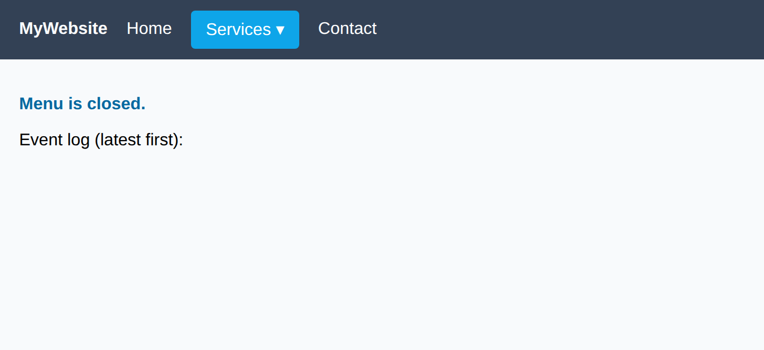
Figure 5.1: Initial state – menu closed, event log empty
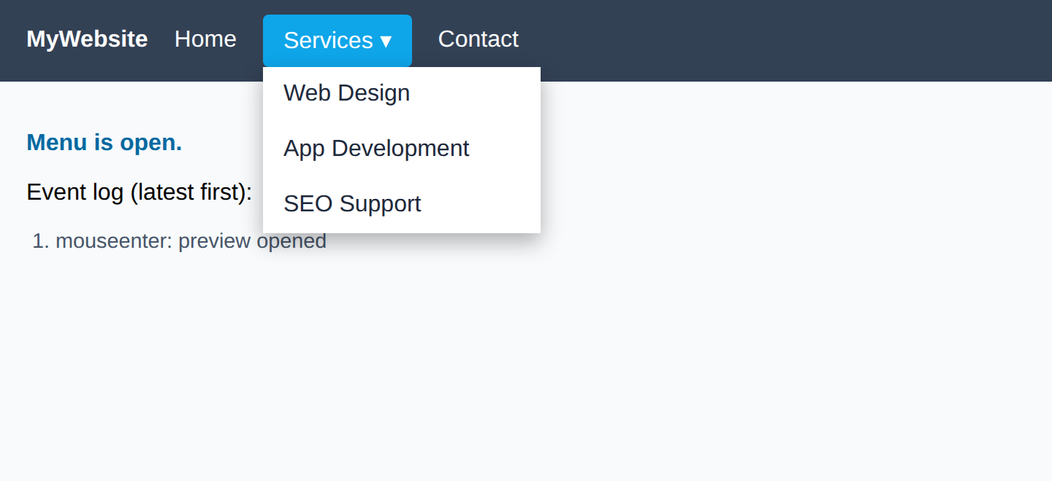
Figure 5.2: Mouse over “Services” – preview opened (mouseenter)
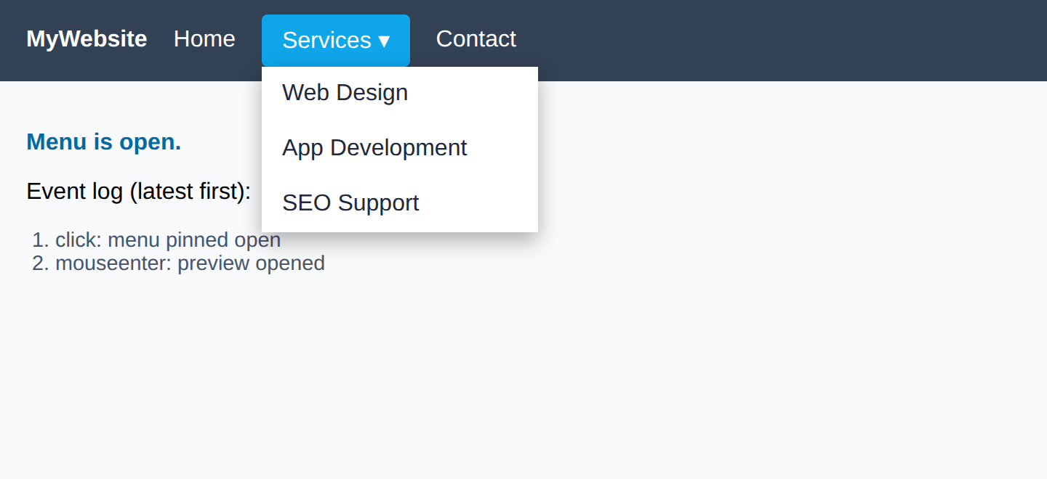
Figure 5.3: Button clicked – menu pinned open and stays open after the mouse leaves
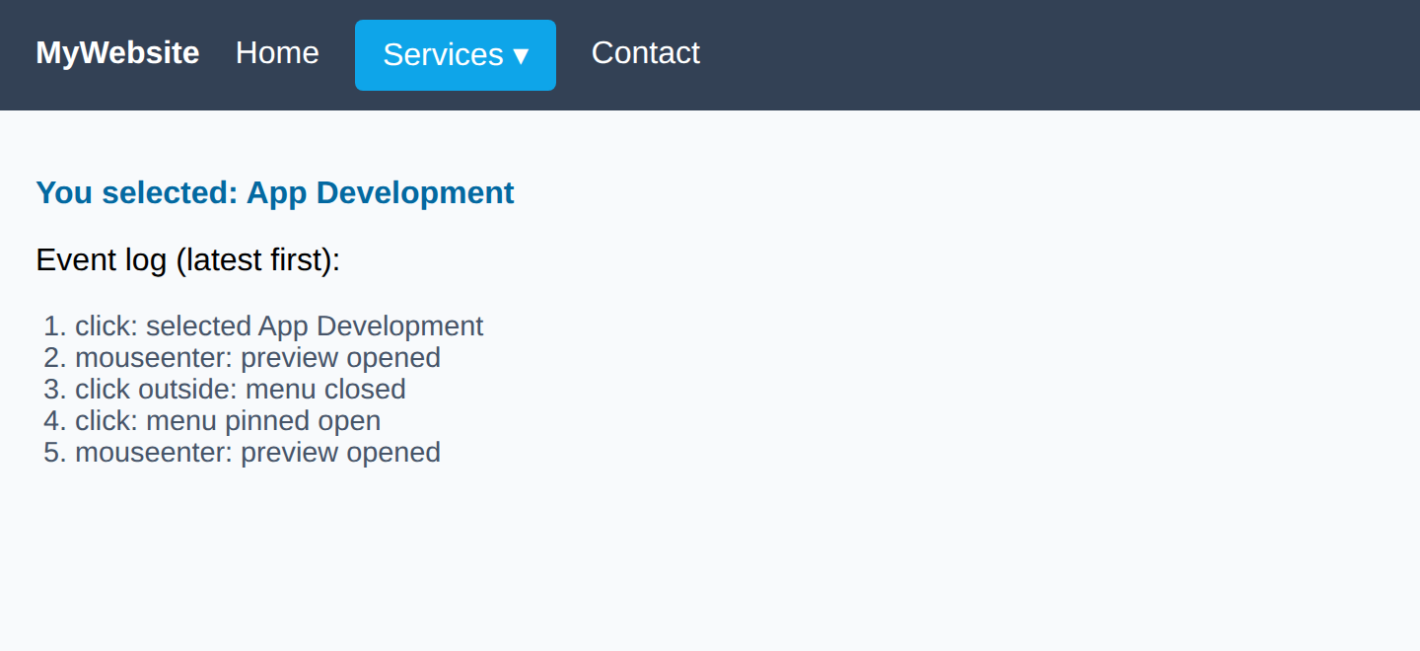
Figure 5.4: “App Development” clicked – menu closed, selection shown
Test results:
User action | Expected result | Observed
Mouse over Services | Preview opens | Opened (Figure 5.2)
Click Services | Menu is pinned open | Stayed open (Figure 5.3)
Click a menu item | Item shown, menu closes | Closed (Figure 5.4)
Click outside / press Esc | Menu closes | Closed; logged in the event log

(d) Performance evaluation and improvements
Aspect | Evaluation
Efficiency | The menu is opened and closed by toggling one CSS class, so the browser applies one style change instead of many inline style changes.
Number of listeners | Event delegation uses one listener for all menu items; adding new items needs no new code.
Device support | The code works with mouse, touch and keyboard; hover handlers are attached only where hover exists.
Accessibility | aria-haspopup, aria-expanded and aria-controls describe the button, and the status text has aria-live=“polite”.
Reliability | A single setOpen() function keeps the visual state, the ARIA state and the message always consistent.

Suggested improvements:
- Add arrow-key navigation inside the menu and trap focus while it is open (role=“menu” and role=“menuitem”).
- Use a short delay (about 150 ms) before closing on mouseleave to avoid accidental closing.
- Use passive listeners and throttling for scroll, resize or mousemove handlers.
- Animate the opening with CSS transitions (opacity and transform) rather than JavaScript timers.
- Remove listeners that are no longer needed when a component is destroyed.
Code of Conduct

I K VENKATA SIVA PRASAD 192325106 certify that this submission is my original work and that I have adhered to the guidelines specified for this assessment. I understand that any violation of academic integrity rules will result in disciplinary action.

Signature of the student: K VENKATA SIVA PRASAD

